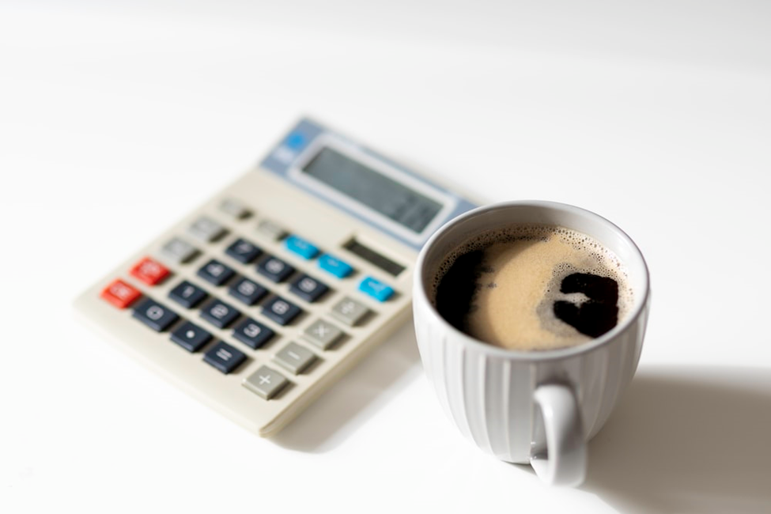

**EATING PI**

We cannot reason ourselves out of our basic irrationality. All we can do is to learn the art of being irrational in a reasonable way.”

- Aldous Huxley

February is often a turbulent month for Abraham. Around this time of year, he transforms into a time traveler in the worst ways. Josephine can tell you. She has the hardest time settling him these days. With the recent release from the hospital and the anniversary coming up, it gets harder to help guide Abe to the present. You never know what year he'd wandered off into next. Days like today are easy reminders for why Abe constantly needs Josephine around. It's been two hours and he's been searching relentlessly for Stephen Hawking's book, A Brief History of Time, but he loaned it to Gabriel, one of his students, a week ago, but in this moment, Abe has absolutely no recollection of even meeting anyone name Gabriel.

.

"He said something about the increase in disorder…giving rise to the flow of time," Abe mumbled to himself, tossing his disheveled astronomy textbooks to the floor. "Something about entropy…and giving way to singularities." He rubbed the scruffy grays on his face and rushed into his living room. The apartment felt unfamiliar to Abe, like he had been here before but two weeks ago with a friend or two for drinks. He was quickly forgetting for the third time this month that this was his new home. His eyes shifted from corner to corner. Towers of books spilled out of his office onto all the coffee tables. Lined across the TV stand was nothing but textbooks in order of publishing dates. Every room in the house was his unofficial library, a space to file away the discombobulated order of literature, topics and subjects he most admired. He and Josephine had developed a special system for keeping track of the chaos. In the armchair was Calculus. Beside the refrigerator was Topology and Geometry. Under his office desk was Number Theory and in the cabinet was, of course, his favorite… Logic.

"Josephine? Where is Book 79?" His question barely made it past his lips to her in the next room. He bent down to look under the stool tables. She was too busy sorting through his mail at the breakfast table to pay attention to his usual frantic pacing. Josephine knew the intricate order of Abe's seemingly disordered library. She had to. For many years, she studied his code, knowing where every book he owned could be. Abraham needs books the way people need air to breathe, and not just any books—Mathematics books. It was her job to know everything her patient needed to survive another day of making sense of his scrambled memories. It was her duty to know every detail about Abe’s life to unburden his mind from holding one more detail. Abe may have studied Mathematics his entire life, but Josephine has studied Abe for over a decade. There isn’t a thing she doesn't know about him. From his allergies to his precise medication dosage, to his favorite pattern on his socks, to the style in which he keeps his teaching notes, to the way he likes his hair cut. How difficult a job it must be to get this forgetful yet brilliant professor to remember his left shoe from his right. If you ask me, it was Josephine who was the true genius here. Yet, any time I chatted with her, she never complained, not once.

"Josephine! For fuck’s sake, woman! Where is Hawking?" He slammed the kitchen cabinet above her head.

She never even lifted her gaze. Fixated on reading through a letter from Abe's physician, she calmly responded:

 "**Seventy-Nine**? Or **Eighty-Nine**?"

"The first one!"

Josephine peered over her silver reading glasses, noticing Abe's agitation. She took a deep breath, then got up and closed each cupboard behind him as he stormed off into the living room. She followed behind slowly. "Did you check the right side of the top shelf in your office? It should be there." Her voice remained even and assuring. She tried to mask the uneasiness in her voice as she anticipated the inevitable. Watching Abe flit from one heap to the next, tossing hard-covered books and loose sheets to the floor, she suspected he was slipping through time again. Quietly, she trailed behind and picked up all the stray papers. The restlessness is usually how it starts. Abe needed an anchor, something to pull him out of his piteous chase for the present. Sudden movements and abrupt interruption only forced him to close off from her. She knew what she had to do. Remain still and wait. She leaned against the door frame with her favorite mug and slowly inhaled the bold fragrance of black tea and uncertainty.

*"*God said something about giving way to a singularity…"

In all the years Josephine worked for this old man, he had never mentioned a single thing about God. Abe was aggressively atheist and found it to be a waste of human breath to start conversations and wars about who made the universe. He worshipped the mathematicians and the astronomers of the twentieth century and must've said a prayer once at his wife's graveside. But the only time he had set foot in a church was the day of his daughter's wedding, which he called a 'circus in a crystal castle'*. What was he on about now? He must be slipping much further today…*Before she could question his blabbering, her watch alarm went off, reminding her to take Abe's lunch out the oven and to promptly prepare his blood pressure pills. She sat her tea down on the marble kitchen counter and silenced the ringing.

"I'll help you look for the book in a minute, but it's lunch time." She announced, "I made Chicken Parm."

Abe felt the dark wooden floor swiftly circling underneath him, but his feet grew heavy and remained glued to the ground. Papers horded his feet as he tried to look through the cabinet.

"I'm telling you, woman! He said something else about pies and I knew he... "

"Doc, come to the table… Do you want orange juice or lemonade?

Abe's favorite foods were always an effective tactic to ground him to the present or at least it was an easy way to gently push him into the last **five** years of his life. His wife knew this best. Each week she cooked the same foods. "Routine," she always said, "reminds Abe of who he is…" Before the chemotherapy sessions started, Cassandra Silvers taught Josephine everything she knew about Abe's condition and all the effective techniques to get him feeling like his regular old self again. She knew it would've been hard on him when she died and after **three** years of battling bone cancer, she had to put measures in place to keep her husband’s wonderful mind intact. It was nothing short of her dying wish. Cassandra ensured his job, his home, and his caregivers were all ready to help him with the transition. At the university, she had spoken with the Dean about keeping Abe for another**five**years before his retirement. That mind of his would grow restless without the classroom. She spent the rest of her lifesavings on a new apartment, and she handpicked his caretaker from the best homecare programs in the State. After **twenty-six** interviews, she was satisfied with no one else but Josephine.

 She checked her watch again. This time she insisted, "Doc, it's time to take your meds; it’s 2 o’clock."

"He told me how the world began…"Abe peeled open Einstein's book Relativity: The Special and The General Theory and rapidly flipped through the pages, desperate to finding meaning in his vision, "...with the firmaments and all those glossy forms of gravitational water." He whispered a few lines from chapter **nine,** tracing his finger along the words. She knew better than to interrupt him for this could very well be the moment where he finds himself again. Averse to leaving him to roam, she quickly grabbed his medicines from the bathroom cabinet. His plate had already been sitting out for few minutes and she knew how much he hated cold chicken. She set his food down in the microwave and set her timer for another **five** minutes.

"There!" He tapped the book like it all had suddenly clicked. Abe scrummaged through yet another pile of textbooks, "Where is my thesaurus?" Possibly searching for the meaning of the word *gravity* yet again, he floated across the living room to the jagged pile closest to the midcentury sofa. *Is there even a synonym for the word gravity?  What is he on about now?* The frenzy was starting to get to her, but she easily masked her vexation. She snatched the thesaurus from the top of a pile on the coffee table and quickly walked back over to him. He flitted from the other end of the couch as she reached over to hand him the book and as he turned around, he tripped over the table's leg. Just before he could slip to the floor she held him by those linen pajama pants, steadied him to his feet, and slowly placed the thesaurus in his hand.

A sharp exhale left them both. He was looking at her but not really. She could see the gears turning. He was trying his best to piece something together, but he was nowhere to be found. The moment was one only she experienced right there in that living room. Abe was out of her grasp. Worry spread through Josephine like wet concrete as she remembered the daunting moments when Abe was this far gone. He left the house without a shirt on a wet, rainy Wednesday, saying he needed to feed his neighbor's dog. Caught in an archaic memory of feeding his best friend's puppy during a summer when he went summer camp without him, Abe left the house in pouring rain knocked on everyone's door and slipped right in front of my porch, fractured his hip and had to be hospitalized for a couple weeks. As strong as he may seem when walking about in his right mind, Abe was still an old, brittle man. Josephine stuffed down her worry and reminded herself that Abe needed an anchor but something else was brewing that she couldn't make sense off. She cross checked her list. He took his medications this morning. She double checked to see if there were any medication that could have cause delirium or hallucination. *Sometimes his antidepressants clash with his morphine pills. He drank his diuretic water... ate breakfast...cornmeal porridge with a fruit cup...without grapes..*.Then a horrifying idea flashed in her mind. She pondered if this had anything to do with the doctor's note that came in the mail but quickly recalled it was sealed before she opened it earlier.

 Abe pressed the thesaurus to his chest while Josephine stood there in her akimbo

" What are you looking for now?"

“It was Pi! Josephine!” Abe in in his aggravation, pushes all the books off the counter "It was Pi!"

“It was the concentric nature of His voice. I could hear it, the hollow music of the Universe. He told me how the whole Universe began...”

"Who? Steven Hawking?" She tried her best understand his reasoning. Josephine bent down to look through spilled pile for A Brief History Of Time. She knew the best thing to do right now was to follow him through the wormhole, to get swept up in the loops of remembrance and follow him across the dimensions of all the lives he has ever lived. As long as she kept her feet on the ground and allowed her own fears to stay at the gateway, she could step into his world of theories about who he had to be today. Trying to trace the books he was interested in was good strategy to taking the quantum leap. It was the breadcrumbs to tracking him in his mind's universe, but he was too unfocused to take her along. She thought the breathing exercise would like they did last time. She began counting.

"Doc, let's count...Deep breath…Inhale"

The old man was in a miserable fit. Irritatedly rubbing his hands over his smooth bald head, he turned to lock eyes with her from across the living room. She slowly stepped towards him " **One...**" He repeated.  Ferociously shaking his head in dismissal, "It was Pi!"

“Calm down, Doc. There’s no reason to be getting all worked up. Tell me what you mean.”

"…What was that thing?... He said something about an ontological war within mankind… Or those silver flower He showed me. It was in the shape of the golden rule...I mean ratio. Beautiful."

“What do you mean?” Josephine was puzzled.  “Who’s *He*?”

“…astounding… you should have seen it. It's everywhere!" Abe paced back and forth. "Insects. Phyllotactic plants.  In the Ocean. In our faces. On my fingertips!”

Josephine grabbed his hand and squeezed him firmly, “Who are you talking about, Doc!”

“God…”

Josephine vividly searched the contours of his perplexed face. She couldn't make sense of him this time. The poor woman felt as though he was slipping through her fingers like grains of sand. An overwhelming sense of loss washed over her for she was never quite sure if the day would come when Abraham would travel in realms of consciousness that her mundane mind could not keep up with. He was outside the observable Universe now, traveling at a million light years away from the living room. Her heart was heavy for she knew he wouldn't suffer long. As good as she was at her job, it was hard for her to see him falling through the cracks like this. This was the first time Josephine ever considered that maybe death was sweet and tending to Abraham was finally coming to a closing chapter. Abe sharply pulled his hands away and glared at her in disgust. Maybe he could tell she had failed him right then and there. Maybe he forgot her for a second. She was never quite sure, but he trembled ever so slightly before her with trepidation.

A familiarity between them escaped the room for a moment but returned with his softened gaze. Abe inched closer and stood there in shameful vulnerability, looking down at the ground in confusion with all the scattered books swarming his feet. The memory waves came crashed down on him so heavily. He melted to the floor and toppled onto her. She softly got down on her knees cradled him in her arms.

Tears slipped unto his flushed cheeks. “It's Pi, Josephine. I asked Him about Cassie...” Abe struggled to get the right words in order, “God said...”

He wailed from the pit of stomach. The hot tears cascaded down his face as he remembered the very last thing he asked God about Cassie. He recalled how she was at peace and waiting for him at the end of the world. He was filled with both sorrow and joy. All he wanted was to be right next to her again, reading the Sunday paper while she watched her favorite sitcom. He longed for her embrace and wondered what took her away so soon. Cassie was waiting on him. That's all that he knew. That's all he could remember. His beloved wife was waiting for him. He was sure God said one more thing, but it was disintegrating right there, in the unreachable parts of his cosmic consciousness. The frustration was crushing him.

"...to eat the pie" he mumbled. "... just like Cassie"

He knew.

"It's Cassie's Birthday! March **fourteenth!"**Abe buried his face in Josephine's neck.  "It was pi..."

Josephine froze in dismay. She pulled Abe closer to her and held him in her bosom. The tears swiftly streamed down her face, as she finally found him adrift in the galaxy of grief. She wept with him. He already knew what she had only moments ago confirmed. After Abe's test labs came back abnormal, the doctors decided to test his injured hip for cancerous growth. It didn't take long, but from that one accident in front of my house, Abe had grown tumors in his fractured hip. A blackhole of anguish swallowed them both as they huddled on the floor. How could he have known? This was news she told no one. Josephine wasn't sure if it was the right choice to ever tell him. All feeling left her stubby legs as the old man bore down his whole weight on her. The truth was unbearable. He knew he was dying. All he could do was softly mutter:

"3.14…

…3.14

3.14…

…3.14…

…3.14"

God told him he was going to die, just like his wife.

"Cassie?" He looked up in Josephine face and caressed her softly, tears overflowing from his soft amber eyes.

"Cassie, is that you?"

**Revision Statemen**t: The challenge in writing Eating Pi was keeping track of perspectives and voices. This is the first time I am writing a short story, and my first time playing around with having the narrator hold a personal yet decentralized role in the narrative. Using myself as “Abe’s neighbor, who is sometimes Josephine’s friend” to guide me was a challenge but I found it necessary to clue into details about Josephine and Abe’s intimacies rather than a neutral all-knowing voice. The narrator was in some ways to be asking the same questions as the audience and finding them difficult to answer. As I revised the story, I questioned the need for Josephine’s inner dialogue and challenged if it was conflicting with my narrator who wouldn’t necessarily be privy to her inner thoughts.

I read up on dementia and Alzheimer's and read personal stories of people who took care of people with these deteriorating mental states. I think contrasting this mental state with someone who was profoundly intelligent to show how they may use alternative ways to store memory was an added layer of dynamism. Many people with high IQs remember information by storing or linking it to something completely unrelated. Abraham’s experience of surviving dementia was using the number system and mathematical or astronomy-themed words. In his attempts to recall a conversation between him and God, he stores the information of “I am going to die of bone cancer, just like my wife” as the number pi, an irrational number that goes on forever. (For what seems more incomprehensible and irrational than death) Pi = 3.141592 is remembered in bits. 3.14 was the anniversary of his wife’s death (March 14th). I highlighted the first 10 digits of pi to show a sort of backward thinking in Abe, as he found his way to reason.

Pi speaks to something deeper about mental states and questions what is rational, what is reason and what does it means to be irrational. With this story, I hoped to challenge the reader to think on the art of being irrational in a reasonable way.”